Project Title

Software Engineering Course Project

Project Design Specification Document



Group ID

Name Roll Number

Name Roll Number

Instructor

Dr. Hamid Abdul Basit

Session 2012-2013

Department of Computer Science

Lahore University of Management Sciences

Lahore

Contents

Project Design Specification Document 3

Use Case Diagram 3

System Architecture 4

System Sequence Diagrams 5

Domain model 6

Sequence diagrams 7

Class diagram 8

(Class Diagram using Entity, Boundary and Control Symbols) 8

(Design Class Diagram with Attributes and Methods ) 8

Collaboration Diagrams 9

State charts 10

DB Schema/ ERD 11

SiteMap 12

Human Interface Design 13

Screens 13

Navigation Flow 14

# Project Design Specification Document

Note: All Diagrams should be in Visio

## Use Case Diagram

Revised use case diagram showing all use cases in one diagram. Use of includes and extends where appropriate.

## System Architecture

MVC, n-tier etc.

Architecture diagram shows the relationship between different components of a system.

Whatever you are using draw a diagram to illustrate how your software and its components (internal and external) fit into a particular architecture.

It could be a combination of the following:

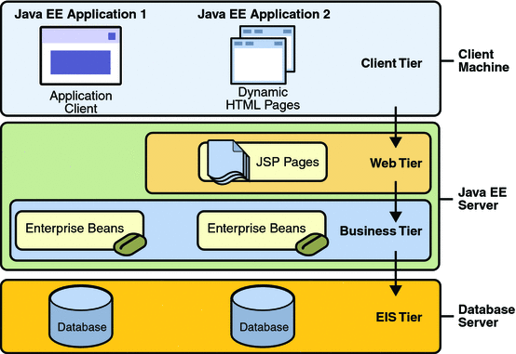

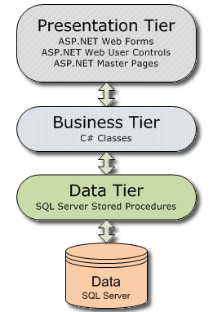

In case of a website, your diagram should clearly indicate the boundaries of your webpages, your application logic and your database. In Visio, you can use the Deployment Diagram toolset to create your architecture diagram. Similarly in case of android apps, if you are following the MVC architecture, then you should explain what constitutes the model, view and controller. The purpose of this diagram is to illustrate what(class, UI form, DB etc.) the various parts of your software are and where they are located(webserver, device, front end, back end etc.) and the communication flow between them.

## System Sequence Diagrams

SSDs illustrate input and output events related to the system under discussion.

(draw one for each use case)(you don’t need to write the scenario in the rectangle, just the diagram)

(be sure to use the activation boxes and object lifelines carefully)

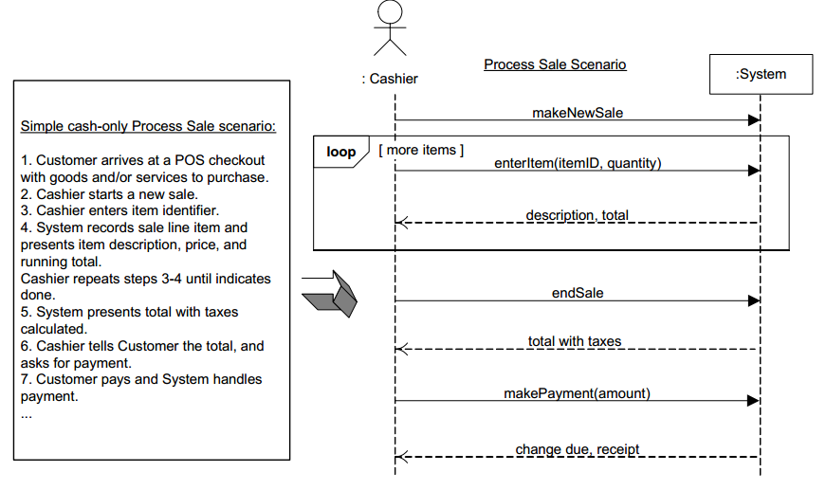

## Domain model

It should model the real world conceptual classes.

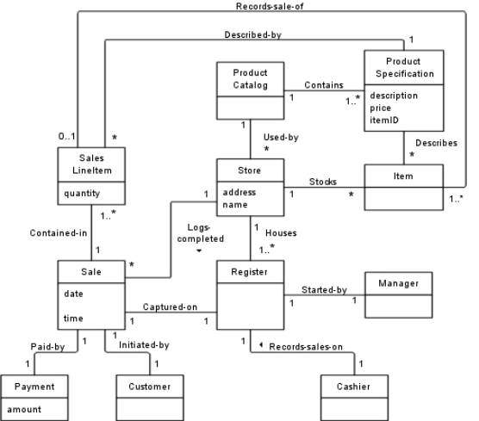

## Sequence diagrams

(one for each use case, showing the entity, boundary and control classes)(rational rose supports the symbols but not possible in visio I think. So just use the available symbols and mark this way e.g. <<entity>>)

Please make sure that appropriate class is calling appropriate message on the other class.

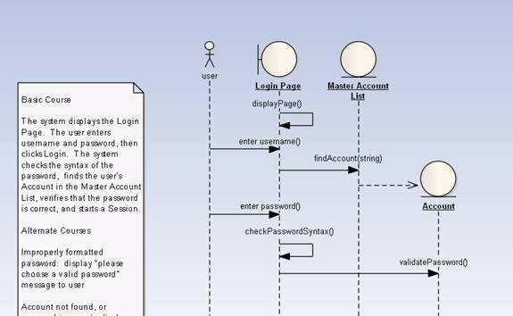

## Class diagram

### (Class Diagram using Entity, Boundary and Control Symbols)

### (Design Class Diagram with Attributes and Methods )

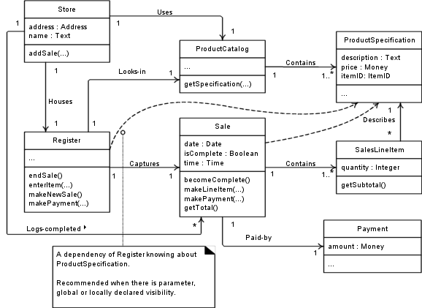

## Collaboration Diagrams

One for each use case

## State charts

One for each use case

## DB Schema/ ERD

(following is a sample ERD for a BIKE Store)(Your ERD can span more than one page)

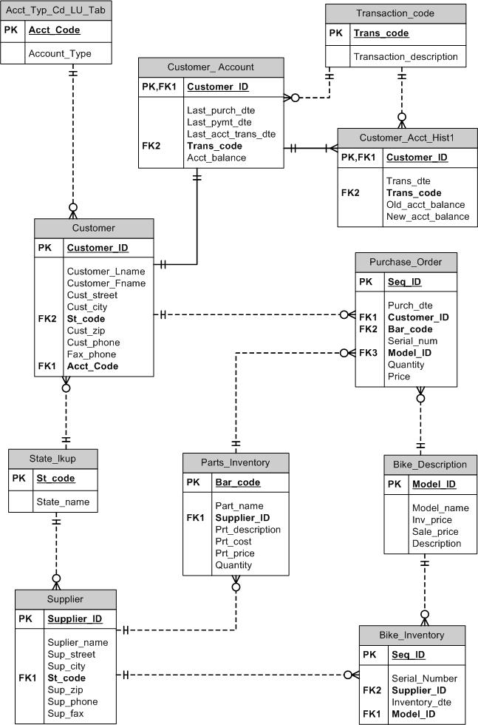

## SiteMap

(especially for websites and android apps)

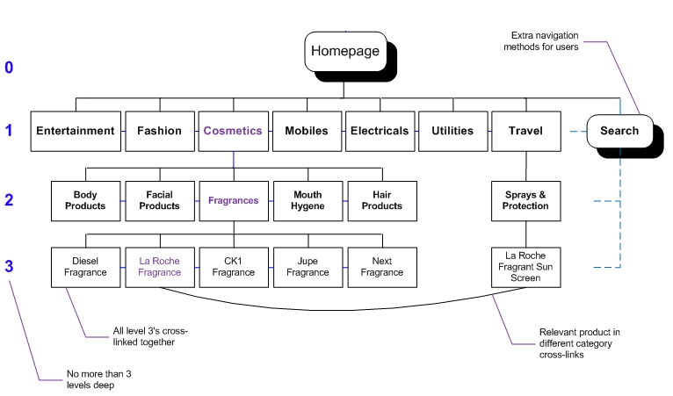

## Human Interface Design

### Screens

Design wireframes for every input screen. All use cases should be covered. You can use any software to design screen prototypes.

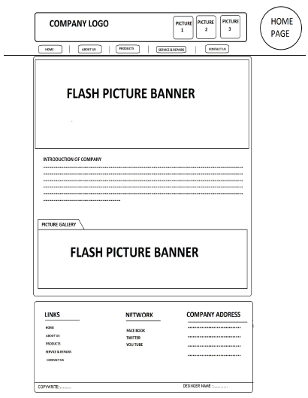

### Navigation Flow

How the screens are connected to each other, which follows which.

